Session 4 Reflection

1. SQLite (1 point)

* Followed all the steps from the setup.sh file.
* Copied the code from the example file and saved it in a .sql file
* Loaded the file and did a simple select command with inner join

2. MySQL (2 points)

* Followed the steps from the files, but didn’t upgrade, because too many upgrades that were breaking the virtual machine,
* Installation was pretty straight forward, although used nano as editor

3. MariaDB (2 points)

I was using an ubuntu image loaded in a virtual machine and I wasn’t able to upgrade it so I had a few failed attempts to install mariadb. At the end I installed the linux ubuntu – 22.10, I’m using it because this is the only ARM version. Once I installed it I had everything missing from the mysql installation, so I had to redo it which I don’t mind, more practice. – fig 1

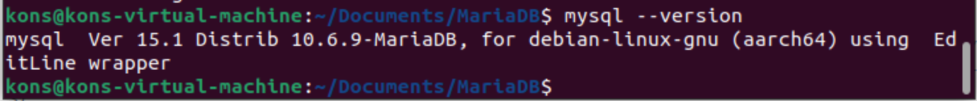

Here is a select command. – fig 2

4. PostgreSQL (2 points)

Followed the steps in the setup file – with a few spelling mistakes – fig 1

Creating the School Database fig 2

Populating it - fig 3 and fig 4

Select with inner join – fig 5

5. Microsoft SQL Server (2 points)

Since I’m running Ubuntu 22.10 on M2 apple chip I wasn’t able to install the docker using the instructions in your file. I was able to do it using the instructions in this website – <https://forums.docker.com/t/cant-install-docker-on-ubuntu-20-04/93058/3>

But after that I got another error message – “Error response from daemon”, I wasted another 4 hours trying to make it run. In the end I read that the 22.10 is still not supported by docker, so I installed VirtualBox on my windows machine and tried it with Ubuntu 22.04 and I managed to run the docker. – fig 1

Of course in order to save time I tried to do it on the image from the disk without installation so the next phase of setup failed due to no disk space, so I had to install Ubuntu and repeat everything again.

Successful pull – fig 2

And in the end I made it work – fig 3

